Create a Virtual Hard Disk and allocate the storage using Vmware Workstation.
Aim:
- Open VMware Workstation on the host system.
- Click Create a New Virtual Machine or select an existing virtual machine.
- If creating a new VM, choose Typical (Recommended) and click Next.
- Select Installer disc image file (ISO) or choose I will install the operating system later.
- Select the Guest Operating System and version.
- Enter a Virtual Machine name and choose the location.
- In the Specify Disk Capacity window:
- Enter the required Virtual Hard Disk size (e.g., 15 GB).
- Choose Store virtual disk as a single file or Split virtual disk into multiple files.
- Click Next and then Finish to create the virtual hard disk.
- To add a disk to an existing VM:
- Select the VM → Click Edit virtual machine settings.
- Click Add → Select Hard Disk → Next.
- Choose SCSI (Recommended).
- Select Create a new virtual disk.
- Specify the disk size and click Finish.
- Power on the VM and format the new disk inside the guest OS if required.
Output:
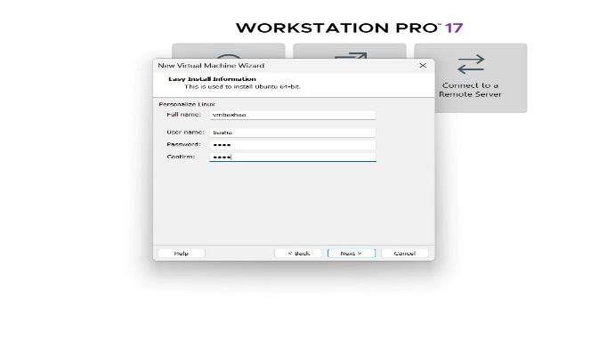
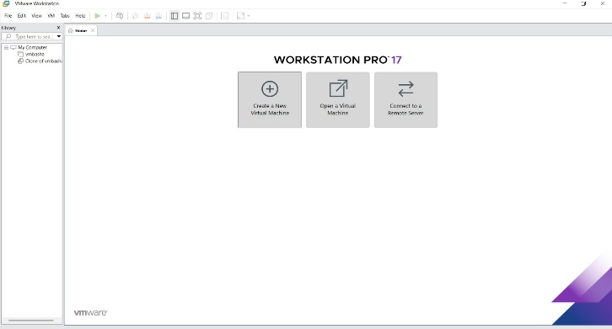

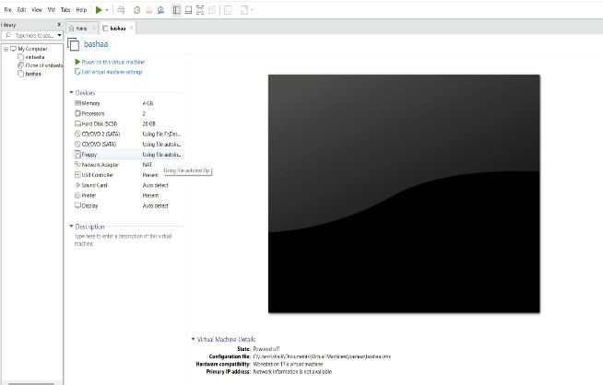
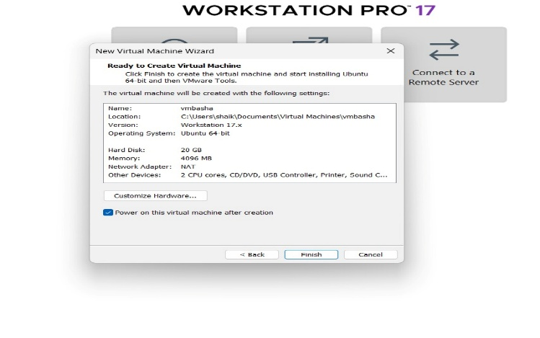
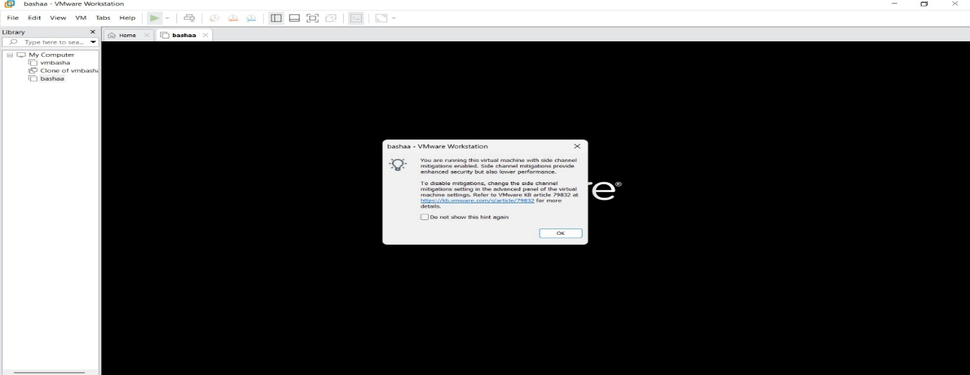
Result: A virtual hard disk was successfully created and storage was allocated using VMware Workstation. The allocated disk was recognized by the virtual machine and used for data storage.

